Results of PAA simulations

# August 7th

## Multigrid method

### Method:

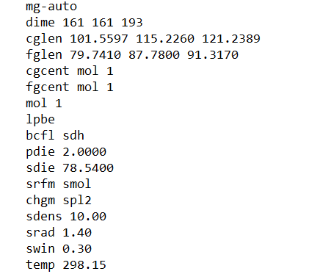

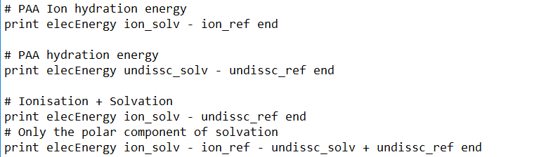

### Calculations:

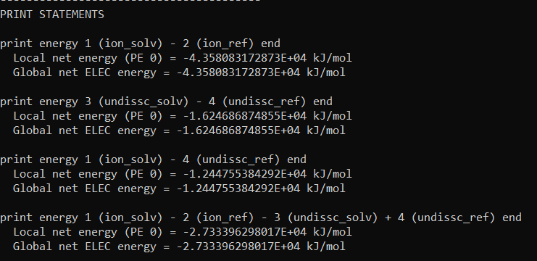

Polar Solvation energy = -2.733*104 kJ/mol

Total solvation free energy = -1.244755*104 kJ/mol

## Multigrid 2

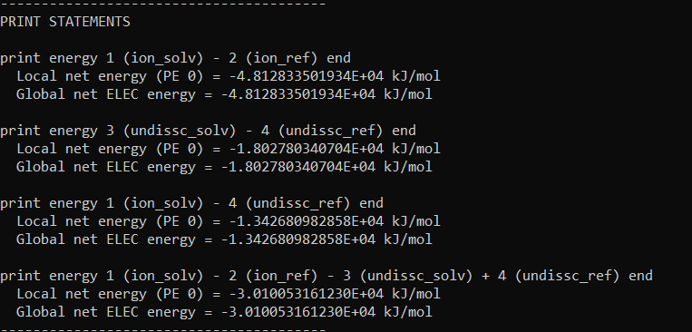

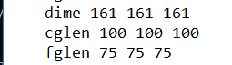

## Multigrid 3

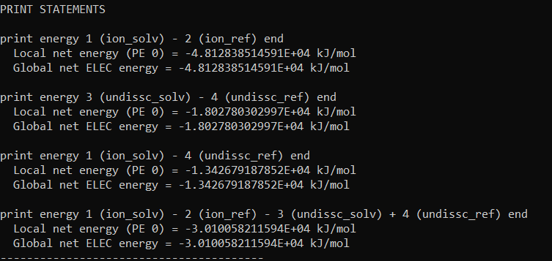

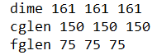

## Geometric Flow Solvation

### Method: molecule chosen: pdb with ions

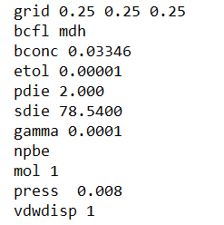

### Results:

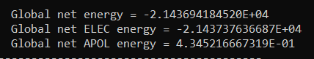

**After decreasing etol to 0.000001**

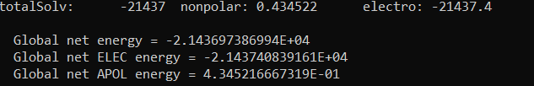

## TABI

**Solvation energy and free energy of undissociated PAA**

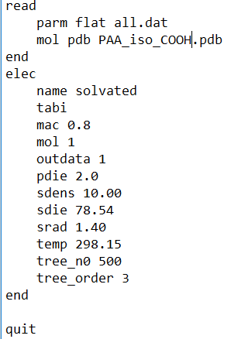

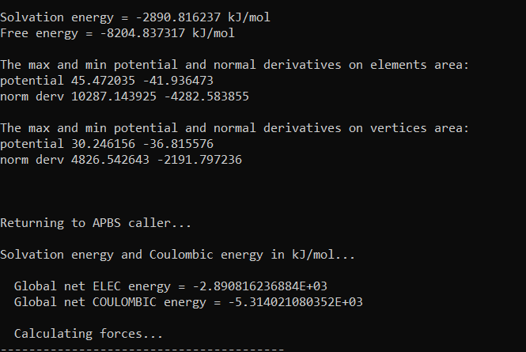

**Solvation and free energy of dissociated PAA**

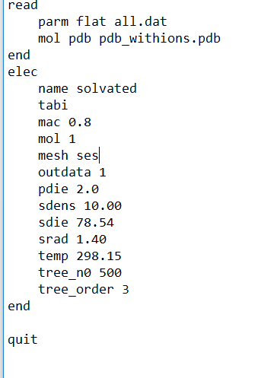

**Used SES Nanoshaper**

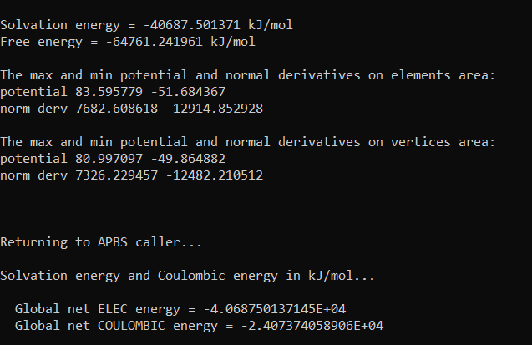

**Solvation energy and free energy of undissociated PAA using SES Nanoshaper**

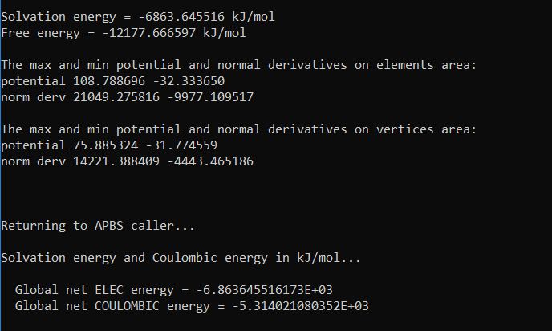

**Therefore, Polar solvation energy = -4*10^4+6.86*10^3 = -3.382*10^4**

# August 10th

## Force calculations using spl2 srfm, npbe, multigrid for ion with Na+

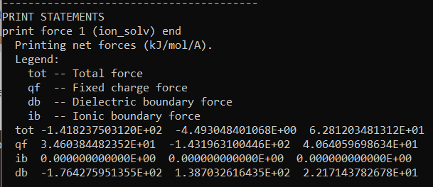

**Srfm spl4 calculation**

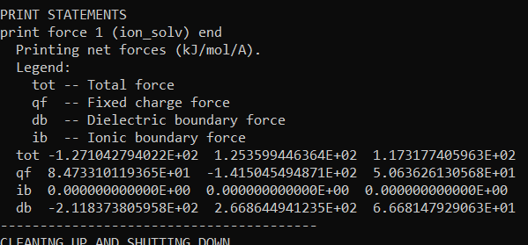

## Similar force calc for undiss PAA

**Srfm spl2**

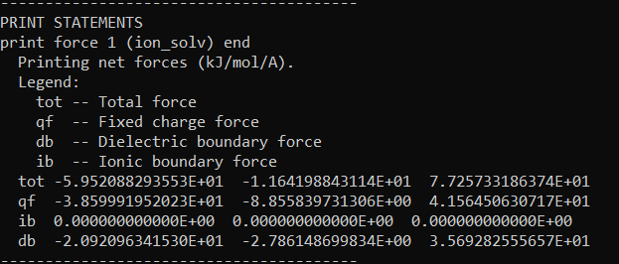

**Srfm spl4**

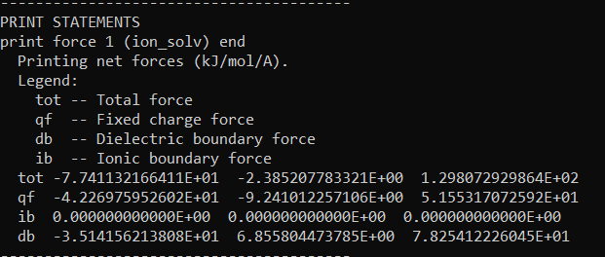

## Solvation with npbe

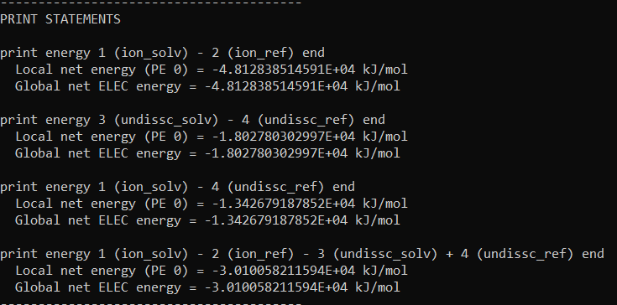

## Surface potentials

### Charged PAA with ions

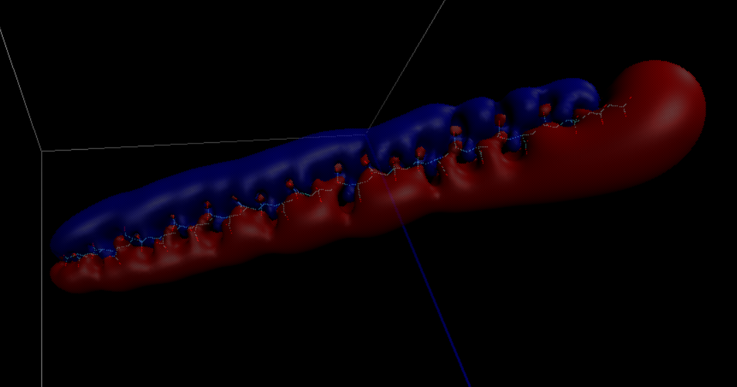

### Uncharged PAA

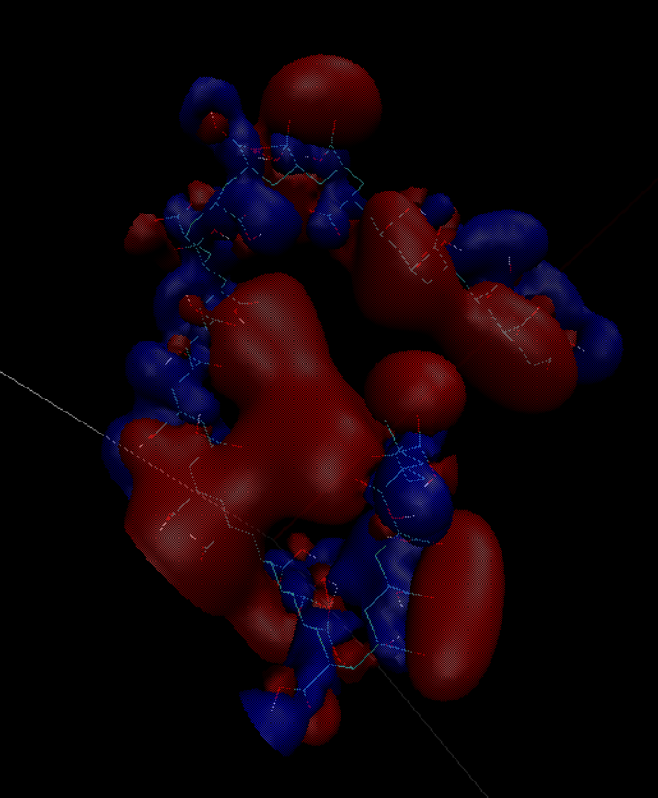

### Charged PAA without ions

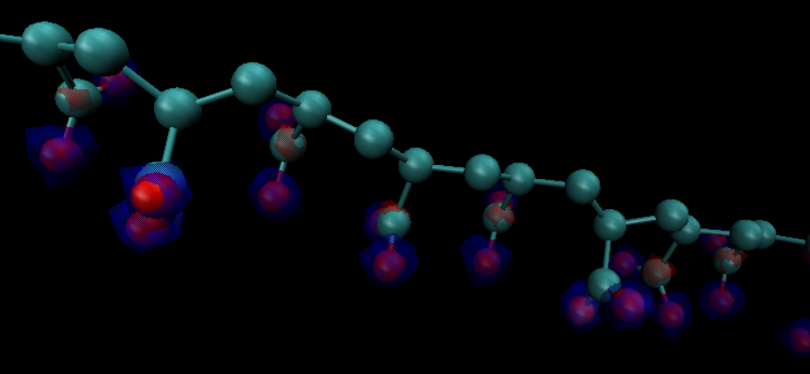

# Update 11/06/2021

Noticed that C1-C3 interchanged in pdb/dat file. So swapped their values in dat file. New simulation for hydration energy gives similar results.

